Name: _SOLUTIONS_______ Chem B Final exam review

Nomenclature
Ag₂S __Gold sulfate_____
Al₂O₃ _____Aluminum oxide___________
H₂SO₄ ______Sulfuric acid______
Fe(OH)₂ ______Iron (II) hydroxide_________
CrCl₃ _____Chromium (III) chloride__________
CaF₂ ___Calcium fluoride_____________
PCl₅ _____Phosphorous pentachloride_________
H₂S ____Hydrosulfuric acid_______
(NH₄)₂SO₄ _____Ammonium sulfate__________
HNO₂ __Nitrous acid________
NiBr₃ __Nickel (III) bromide_____________
silicon dioxide ___SiO₂____ nickel (III) sulfide ______Ni₂S₃___________________

manganese (II) phosphate ____Mn₃(PO₄)₂_________ silver acetate _______AgC₂H₃O₂______________

diboron tetrabromide ___B₂Br₄_______________ magnesium sulfate heptahydrate ___MgSO₄·7H₂O___

potassium carbonate ____K₂CO₃______________ ammonium oxide ___(NH₄)₂O____

tin (IV) selenide ______SnSe₂________________ carbon tetrachloride ______CCl₄_________________

Balanced Chemical Equations
Write a balanced chemical equation with state symbols from the given information.
- Sodium reacts with oxygen
4Na_{(s)} + O_{2 (g)} 2Na₂O _{(s)} Synthesis/Combustion rxn

- Zinc reacts with hydrochloric acid
Zn_{(s)} + HCl _{(aq)} ZnCl _{(aq)} + H_{2 (g)} Single replacement rxn

- Chlorine reacts with sodium iodide
Cl_{2 (g)} + NaI _{(aq)} NaCl _{(aq)} + I_{2 (g)} Single replacement rxn

- A solution of copper(II) phosphate and magnesium
Cu₃(PO₄)_{2 (aq)} + Mg _{(s)} Mg₃(PO₄)_{2 (aq)} + Cu _{(s)} Single replacement rxn

- Silver oxide is heated
2Ag₂O_{(s)} 4Ag_{(s)} + O_{2 (g)} Decomposition rxn

- Solutions of mercury(II) acetate and ammonium carbonate react
Hg(C₂H₃O₂)_{2 (aq)} + (NH₄)₂CO_{3 (aq)} HgCO_{3 (s)} + 2NH₄C₂H₃O_{2 (aq)} Double displacement rxn

- Cadmium and oxygen are combined
Cd _{(s)} + O₂ CdO _{(s)} Synthesis/Combustion rxn

- Aluminum chlorate decomposes with an electric current
2Al(ClO₃)₃ _{(s)} 2AlCl₃ _{(s)} + 9O_{2 (g)} Decomposition rxn

- Nitric acid is reacted with potassium hydroxide
HNO₃ _{(aq)} + KOH _{(aq)} HOH _{(l)} + KNO_{3 (aq)} Double displacement rxn
OR (HNO₃ _{(aq)} + KOH _{(aq)} H₂O _{(l)} + KNO_{3 (aq)})

- Solutions of lead nitrate and sodium iodide react
Pb(NO₃)_{2 (aq)} + NaI _{(aq)} PbI₂ _{(s)} + 2NaNO_{3 (aq)} Double displacement rxn

Percent Composition

- What is the percent composition of water, H₂O?
$$\% \left(by mass\right) H= \frac{2(1.0079 g H)}{18.0152 g H_{2}O_{}}×100\%=11.2 \% H$$
$$\% \left(by mass\right) O= \frac{1(15.9994 g O)}{18.0152 g H_{2}O_{}}×100\%=88.8 \% O$$

- What is the percent composition of glucose, C₆H₁₂O₆?

$$\% \left(by mass\right) C= \frac{6(12.011 g C)}{180.157 g {C_{6}H}_{12}O_{6}}×100\%=40.0 \% C$$

$$\% \left(by mass\right) H= \frac{12(1.0079 g H)}{180.157 g {C_{6}H}_{12}O_{6}}×100\%=6.7 \% H$$
$$\% \left(by mass\right) O= \frac{6(15.9994 g O)}{180.157 g {C_{6}H}_{12}O_{6}}×100\%=53.7 \% O$$

Empirical Formulas

- A compound consists of 72.2% magnesium and 27.8% nitrogen by mass. What is the empirical formula?
$$72.2 g Mg×\frac{1 mole Mg}{24.31 g Mg }=2.97 mol Mg$$
$$27.8 g N×\frac{1 mole N}{14.01 g N }=1.98 mol N$$

$$\frac{1.98 mol N}{1.98 mol N}=1 mol N$$

$$\frac{2.97 mol Mg}{1.98 mol N}=1.5 mol Mg$$
Multiply both by 2 to get lowest whole number ratio
Therefore the EF is Mg₃N₂

- A compound is analyzed and found to contain 68.54% carbon, 8.63% hydrogen, and 22.83% oxygen. The molecular weight of this compound is known to be approximately 140 g/mol. What is the empirical formula? What is the molecular formula?

Determining the empirical formula:
$$68.54 g C×\frac{1 mole C}{12.011 g C }=5.71 mol C$$
$$8.63 g H×\frac{1 mole H}{1.0079 g H }=8.56 mol H$$
$$22.83 g O×\frac{1 mole O}{15.9994 g O }=1.42 mol O$$
$$\frac{1.42 mol O}{1.42 mol O}=1 mol O$$
$$\frac{5.71 mol C}{1.42 mol O}=4.02 mol C$$
$$\frac{8.56 mol H}{1.42 mol O}=6.03 mol H$$
Thus the EF is C₄H₆O
Determining the molecular formula:
Molar Mass of MF: 140 g/mol
Molar Mass of EF: (4x12.011 g/mol C) + (6 x 1.0079 g/mol H)
+ (15.9994 g/mol O) = 70.09 g/mol C₄H₆O

140 g/mol = X x 70.09 g/mol C₄H₆O.
Thus X=2 and the MF is 2x C₄H₆O or C₈H₁₂O_{2.}

Stoichiometry

- Write the balanced equation for the reaction of lead (II) nitrate with sodium iodide to form sodium nitrate and lead (II) iodide.

Pb(NO₃)_{2 (aq)} + 2NaI _{(aq)} PbI₂ _{(s)} + 2NaNO_{3 (aq)}

- If I start with 25.0 grams of lead (II) nitrate and 15.0 grams of sodium iodide, how many grams of sodium nitrate can be formed?

$$25.0 g {Pb({NO}_{3})}_{2} ×\frac{1 mol {Pb({NO}_{3})}_{2}}{331.2 g {Pb({NO}_{3})}_{2}}×\frac{2 mol Na{NO}_{3}}{1 mol {Pb({NO}_{3})}_{2}}×\frac{84.99 g Na{NO}_{3}}{1 mol Na{NO}_{3}}=12.8 g Na{NO}_{3}$$

$$15.0 g NaI ×\frac{1 mol NaI }{149.89 g NaI }×\frac{2 mol Na{NO}_{3}}{2 mol NaI }×\frac{84.99 g Na{NO}_{3}}{1 mol Na{NO}_{3}}=8.51 g Na{NO}_{3}$$

- What is the limiting reactant in the reaction described in problem 2?

$∴NaI$ is the limiting reagent and 8.51g NaNO₃ can be produced.

- What is the percent yield if 6.92 g of sodium nitrate were formed? (81.3 %)

$$Percent yield=\frac{AY}{TY}×100\%=\frac{6.92 g Na{NO}_{3}}{8.51 g Na{NO}_{3}}×100\%=81.3\%$$

Phases of Matter

- What are the three assumptions that kinetic theory makes about the properties of gases?
(There are actually five. The bolded ones are the most important).
- Gases consist of very small particles that are far apart relative to their size.
- Gases are in constant, random motion. They constantly collide with each other and the walls of the container.
- Collisions between molecules or molecules and the container walls are elastic.
- There are no forces of attraction or repulsion between gas molecules.
- The temperature of the gas is depend on the average kinetic energy of the gas particles.

- Convert 892 mmHg to atm and to kPa:
$$892 mmHg ×\frac{1 atm }{760 mmHg }=1.17 atm$$
$$892 mmHg ×\frac{101.3 kPa}{760 mmHg }=118.9 kPa$$

- A. Compare the average kinetic energy of a glass water bottle and the average kinetic energy of the liquid water in the bottle. (i.e. Do they have the same ave KE or are they different?)

Because they are at the same temperature (which is the way we measure average kinetic energy), they must have the same aveKE.

  - B. Why do we see a difference in phases if they are at the same temperature? What factor dictates the phase of a substance?
We see a difference in their phases at the same temperature because of their differences in intermolecular forces (IMFs). The molecules in glass are vibrating with the same aveKE as the aveKE of the liquid water molecules that are slipping past each other. The same can be said for the air molecules flying around inside the bottle. They all have the same ave KE but have different IMFs which dictate the state of matter at any given temperature and pressure.

- Arrange the states of matter with respect to their orderliness.

(most restricted motion and highest IMFs) Solids < Liquids < Gases (most random motion and least amount of IMFs)

- Draw a series of pictures (from memory if possible!) to show the process of heating a liquid to boiling.

BOILING SHOWN BELOW:
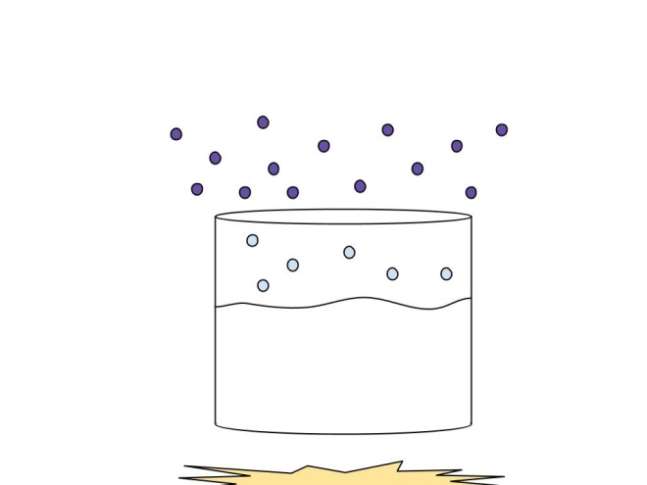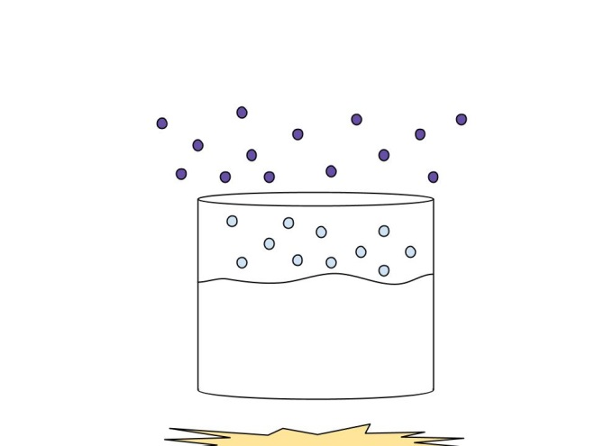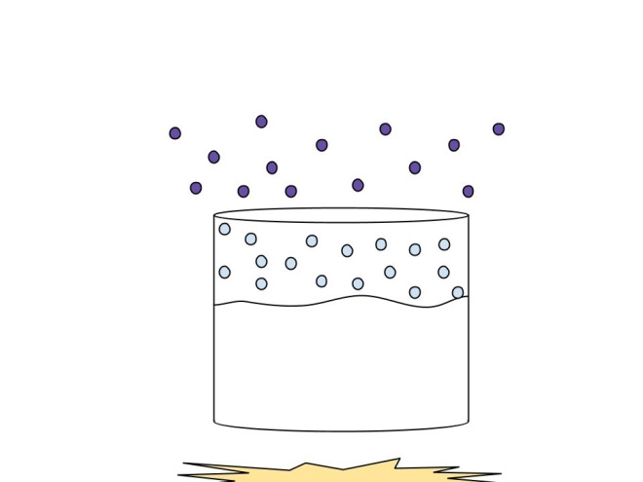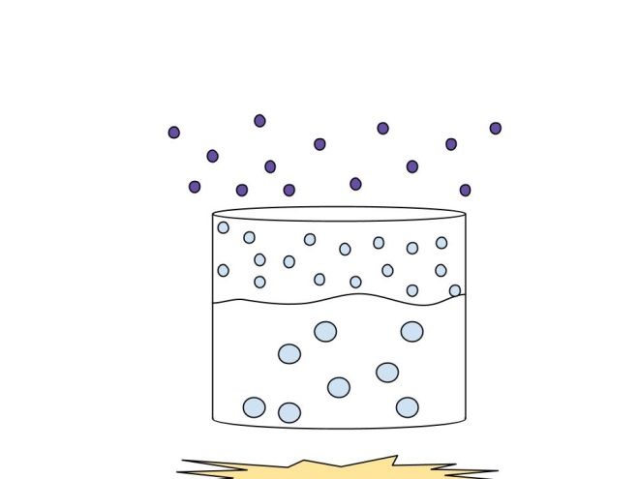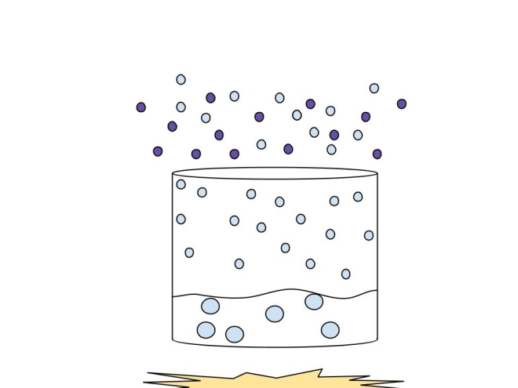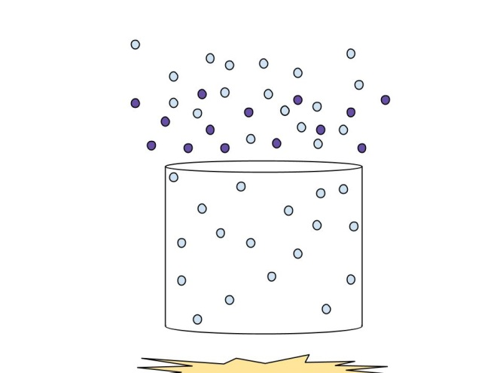
Process of boiling a solution

EVAPORATION SHOWN BELOW:

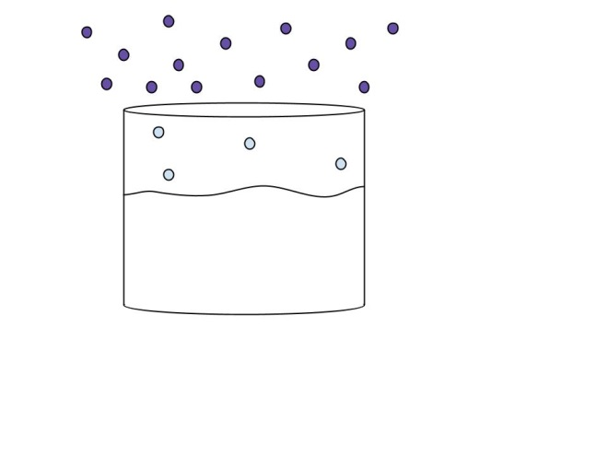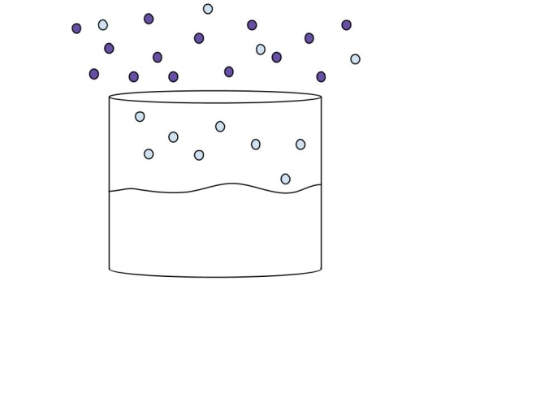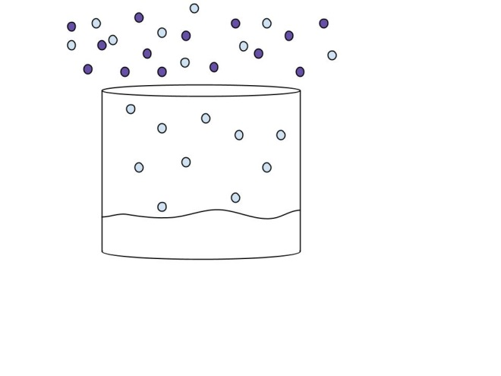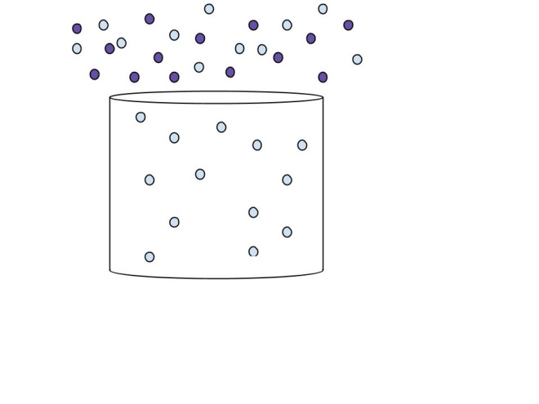
Process of evaporation

- Is the boiling point of water at the top of Mount McKinley (the highest point in North America) higher or lower than it is in Death Valley (the lowest point in North America)? (Lower… but why?)

The atmospheric pressure decreases as altitude increases. Thus less VP is required to bring water to boiling. Water boils at lower temperatures as altitude increases. Thus water will boil at a lower temperature at the top of a mountain than in Death Valley. HOWEVER, this means that we have to cook food for longer at higher altitudes because the temperature of boiling water is lowered.

- Draw a heating curve for water and label the diagram with (Hint: axes should be labelled as Kinetic Energy vs. Time/heating):
  - Melting point
  - Boiling point
  - Describe how the kinetic energy of the particles is changing/not changing from -50 degrees C to 0 degrees C.
KE of the particles increases along sloped lines as the particles begin to vibrate/move faster.

  - Describe how the kinetic energy of the particles is changing/not changing at 0 degrees C.
KE of particles doesn’t change at 0 degrees (flat line) because all added energy is going into breaking the IMFs holding molecules together as a solid. (The remaining IMFs will be broken once molecules are heated to 100 degrees C).
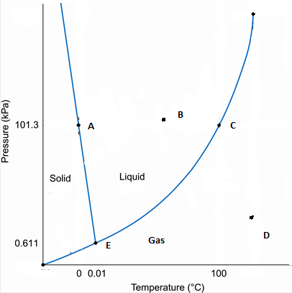
- What phases are present at:
  - Point A: ____solid and liquid_____________
  - Point B: ________liquid_______________
  - Point C: _________liquid and gas______________
  - Point D: ________gas_______________
  - Point E: ______all three________________

- Given that your substance is under the conditions of Point D, what changes need to made to the system in order to bring that substance to:
  - Point A: ____decrease T and increase P____
  - Point B: ____ decrease T and increase P ___
  - Point E: ___ decrease T and decrease P ________

Gases

- The pressure of a sample of gas was 97.8 kPa and the volume of the gas was 3.75 L. If the gas occupied a container with a volume of 8.00 L, what would the pressure in the container be? (ans. 45.8 kPa)
$$\frac{P_{1}V_{1}}{n_{1}T_{1}}=\frac{P_{2}V_{2}}{n_{2}T_{2}}$$
$$\left(97.8 kPa\right)\left(3.75L\right)=P_{2}(8.00L)$$
P₂ = 45.8 kPa

- A gas is initially at a pressure of 225 kPa and a temperature of 245 K in a container that is 4.5 L. If the gas is compressed to a volume of 2.1 L and the temperature changes to 275 K, what is the new pressure?(ans. 540 kPa)
$$\frac{P_{1}V_{1}}{n_{1}T_{1}}=\frac{P_{2}V_{2}}{n_{2}T_{2}}$$
$$\frac{\left(225 kPa\right)\left(4.5L\right)}{245 K}=\frac{P_{2}(2.1L)}{275 K}$$
P₂ = 541 kPa

- Under water where the temperature is 17ºC and the pressure is 394 kPa, a diver inhales 2.1 L of air from his SCUBA tank. If the diver swims to the surface without exhaling where the temperature is 32ºC and the pressure changes to 100.2 kPa, what will the volume of the air in his lungs be? (ans. 8.7 L)
$$\frac{P_{1}V_{1}}{n_{1}T_{1}}=\frac{P_{2}V_{2}}{n_{2}T_{2}}$$
$$\frac{\left(394 kPa\right)\left(2.1L\right)}{(273+17) K}=\frac{(100.2kPa)V_{2}}{(273+32) K}$$
V₂ = 8.68 L

- At a pressure of 103 kPa and a temperature of 22ºC, 52.9 g of a certain gas has a volume of 31.5 L. What is the identity of this gas? (ans. 40 g/mol, argon)
$$PV=nRT$$
$$n=\frac{(103 kPa)(31.5L)}{\left(8.31\frac{kPaL}{molK}\right)(295K)}=1.32 mol$$
$$MM=\frac{52.9 g}{1.32 mol}=40.1 g/mol$$

- In a reaction, 24.9 L of N₂ reacts with excess H₂ to produce NH₃. The pressure in the lab is 97.8 kPa and the temperature was 23.7ºC. How many liters of NH₃ were produced? (ans.44.2 L)
This can be done in a few ways. The way that I’ll do it is by using the combined gas law to determine the volume a gas takes up at these conditions.
$$\frac{P_{1}V_{1}}{n_{1}T_{1}}=\frac{P_{2}V_{2}}{n_{2}T_{2}}$$

$$\frac{(101.3kPa)(22.4L)}{(273K)}=\frac{(97.9kPa)V_{2}}{(296.7K)}$$
V₂ = 25.2 L.

Now use stoichiometry to determine liters of NH₃ produced:

N₂ + 3H₂ 2NH₃

$$24.9 L N_{2}×\frac{1 mol N_{2} }{25.2 L}×\frac{2 mol {NH}_{3}}{1 mol N_{2} }×\frac{25.2 L {NH}_{3}}{1 mol {NH}_{3}}=49.8 L {NH}_{3}$$

- The combustion of a certain wax can be represented by the following balanced equation:
C₂₂H₄₄ + 33 O₂ 22 CO₂ + 22 H₂O
If 185g of wax (C₂₂H₄₄) burns, how many liters of oxygen gas were used up? Assume the conditions in the lab are 101 kPa and 25ºC. (ans. 486 L)
This again can be done in a few ways. I’ll use the Ideal Gas Law this time so you can get a sense of what this would look like. You’ll use stoichiometry first to calculate the number of moles of O₂ used in this reaction and then use IDL to convert that to liters. (Alternatively, the same process from 5 could be done to determine the L/mol at these conditions for any given gas).

$$185 g C_{22}H_{44}×\frac{1 mol C_{22}H_{44} }{308.59 g C_{22}H_{44}}×\frac{33 mol O_{2}}{1 mol C_{22}H_{44} }=19.78 mol O_{2}$$

$$PV=nRT$$
$$V=\frac{\left(19.78 mol\right)\left(8.31\frac{kPaL}{molK}\right)\left(298K\right)}{\left(101 kPa\right)}=485 L$$
- Predictions
- If the pressure of a gas increases, the volume ______decreases__________________
- When the temperature of a gas is lowered, the volume _______decreases______________
- When the temperature of a gas is lowered, the pressure _____________decreases________
- If a container of gas is “squished” (technical gas term), the pressure will ___increase___________

- For the reaction 2 H_{2(g)} + O_{2(g)} 2 H₂O_{(g)}
- How many liters of water can be made from 5 L of oxygen gas and an excess of hydrogen at STP? (ans. 10 L)
$$5 L O_{2}×\frac{1 mol O_{2} }{22.4 L}×\frac{2 mol H_{2}O}{1 mol O_{2} }×\frac{22.4 L H_{2}O}{1 mol H_{2}O}=10 L H_{2}O$$

- How many liters of water can be made from 55 grams of oxygen gas and an excess of hydrogen at STP? (ans. 77 L)
$$55 g O_{2}×\frac{1 mol O_{2} }{32 g O_{2} }×\frac{2 mol H_{2}O}{1 mol O_{2} }×\frac{22.4 L H_{2}O}{1 mol H_{2}O}=77 L H_{2}O$$

- A sample of gas occupies 12.3 L at 21 ºC and 1.75 atm. How many moles are present? (ans. .89 mol)
$$PV=nRT$$
$$n=\frac{(1.75 atm)(12.3L)}{\left(0.082 \frac{atmL}{molK}\right)(294K)}=10.9 mol$$

- Determine the pressure change when a constant volume of gas at 1.00 atm is heated from 20.0 °C to 50.0 °C. (ans. 1.10 atm)
$$\frac{P_{1}V_{1}}{n_{1}T_{1}}=\frac{P_{2}V_{2}}{n_{2}T_{2}}$$

$$\frac{(1atm)}{(293K)}=\frac{P_{2}}{(323K)}$$
P₂ = 1.10 atm.

- How much faster will a molecule of fluorine travel than a molecule of iodine? (ans. 2.58x)
$$\frac{{rate}_{lighter}}{{rate}_{heavier}}=\frac{{rate}_{F_{2}}}{{rate}_{I_{2}}}=\sqrt{\frac{{MM}_{I_{2}}}{{MM}_{F_{2}}}}=\sqrt{\frac{253.8 g/mol}{38 g/mol}}=2.58$$
Thus molecules of F₂ will travel 2.58x faster than I₂ molecules when under the same temperature and pressure conditions.

Solutions

- How many grams of K₂S are required to make 425 ml of a 1.5 M solution of K₂S? (ans. 7.0x10¹g)

$$M=\frac{mol solute}{L solution}$$

$$0.425 L×\frac{1.5 mol K_{2}S}{1 L}×\frac{{110.3 g K}_{2}S}{1 mol K_{2}S }=70.3{ g K}_{2}S$$

- How many moles of NaCl are in 325 ml of a 2.5 M solution? (ans. .81 mol)
$$M=\frac{mol solute}{L solution}$$

$$0.325 L×\frac{2.5 mol NaCl}{1 L}=0.81 mol NaCl$$

- If a chemist wanted to dilute 6.0 M HCl to make 550 ml of .5 M HCl, how many ml of the concentrated acid would she need? (ans. 46ml)

$$M_{1}V_{1}=M_{2}V_{2}$$
$$\left(6.0M\right)V_{1}=\left(550mL\right)\left(0.5M\right)$$

V₁ = 45.8 mL

- What is the molarity of 45.1 g CoSO₄ in 250.0 mL of solution? (ans.1.16M)

$$M=\frac{mol solute}{L solution}$$

$$45.1 g Co{SO}_{4}×\frac{1 mol Co{SO}_{4}}{154.996 g Co{SO}_{4}}×\frac{1}{0.25 L }=1.16 M Co{SO}_{4} solution$$

- What is the molality of a solution made by dissolving 36.5g of naphthalene (C₁₀H₈) in 425g of toluene (C₇H₈)? (ans. .670m)

$$m=\frac{mol solute}{kg solvent}$$

$$36.5 g C_{10}H_{8}×\frac{1 mol C_{10}H_{8}}{128.17 g C_{10}H_{8}}×\frac{1}{0.425 kg C_{7}H_{8} }=0.670 m C_{10}H_{8} solution$$

- A 4 g sugar cube (Sucrose: C₁₂H₂₂O₁₁) is dissolved in a 350 ml teacup of 80 °C water. What is the percent composition by mass of the sugar solution? (ans. 1%)
Remember 1 mL water = 1 g water because of water’s density!!
$$\% sugar \left(\frac{m}{m}\right)=\frac{4 g sugar cube}{354 g solution}×100\%=1.1\% sugar solution$$

- A windshield washer solution is made of 36 mL of methanol and 56 mL of water. What is the concentration of methanol in the solution expressed as percent by volume of methanol? (ans. 39%)
$$\% methanol \left(\frac{v}{v}\right)=\frac{36 mL methanol}{92 mL solution}×100\%=39\% methanol solution$$

- What is the boiling point elevation of a solution made from 70.0 g of C₆H₁₂O₆ and 425.6 ml of water? (ans. .47ºC)
$$70.0 g C_{6}H_{12}O_{6}×\frac{1 mol C_{6}H_{12}O_{6}}{180 g C_{6}H_{12}O_{6}}×\frac{1}{0.4256 kg{ H}_{2}O }=0.914 m$$
$$∆T_{b}=K_{b}i m=\frac{0.515 ℃}{m}×1×0.914 m=0.47 ℃$$

- What is the freezing point of a solution containing 80.5 g CaBr₂ in 525 ml H₂O? (ans. -4.29ºC)

$$80.5 g {CaBr}_{2}×\frac{1 mol {CaBr}_{2}}{199.89 g {CaBr}_{2}}×\frac{1}{0.525 kg{ H}_{2}O }=0.767 m$$
$$∆T_{f}=K_{f}i m=\frac{1.86 ℃}{m}×3×0.767 m=4.28 ℃$$
$$T_{f}=0°C-∆T_{f}=-4.28 ℃$$

- Calculate the solubility of carbon dioxide in water at 0 C and a pressure of 3.00 atm. The solubility of carbon dioxide is 0.348 g/100 mL water at 0 C and 1.00 atm. (Henry’s Law) (ans. 1.04g/100ml)

$$\frac{{sol}_{a}}{P_{a}}=\frac{{sol}_{b}}{P_{b}}$$

$$\frac{0.348 g/100mL}{1 atm}=\frac{{sol}_{b}}{3 atm}$$

Sol_{b} = 1.04 g/100mL

- List the two colligative properties and the effect on them when a solute is added to a solvent.

Freezing point depression and boiling point elevation. Both occur due to the lowering of the solvent’s vapor pressure with the addition of solute.

- Which of the following compounds in solution will result in the greatest elevation in B.P.? Explain.
Na₂SO₄ C₃H₈O AgCl

- Will more salt dissolve in water when the water temperature is high or when the water temperature is low? Explain.
Water molecules are moving faster at higher temperatures and thus collide more often with the solute. Increasing the collisions will increase the rate of dissolution (i.e. the process where water pulls the compound into ions).

- Will more salt dissolve in water when the salt crystals are small or large? Explain.
Increasing the surface area of the solute allows for water molecules to collide with the solute particles more often. Increasing the collisions will increase the rate of dissolution (i.e. the process where water pulls the compound into ions).

- Will more salt dissolve in water when the solution is agitated or left alone? Explain.
Increasing agitation will allow water molecules to collide with the solute particles more often. Increasing the collisions will increase the rate of dissolution (i.e. the process where water pulls the compound into ions).

- Will more gas dissolve in water when the water is warm or when the water is cold? Explain.

Gas solubility increases with increasing pressure.

- Use the terms unsaturated, saturated, and supersaturated solutions in explain a salt solution.

These mark different degrees of concentration of a solution. Each solute-solvent pair will have different saturation points which are pressure and temperature dependent.

- Which of the following would be electrolytes? LiF NO₂ CCl₄ CaO BeI₂

- What is a simple way of explaining the term solvation?

The process of ionic compounds breaking into ions when placed in water.

- Be able to distinguish between a solution, colloid, or a suspension in terms of particle size, ability to be filtered, and effect on light.

- Know what an emulsion is.

- Understand what the terms vapor pressure, boiling point, freezing point are and why they differ for different substances.

- Be able to understand the effect of hydrogen bonds on the surface tension of water and the properties of water.

Name the following hydrates: Write the formulas for the following hydrates:

FeCl₃. 6 H₂O barium chloride dihydrate
Iron (III) chloride hexahydrate BaCl₂ . 2 H₂O

CuSO₄ . 5 H₂O magnesium sulfate heptahydrate
Copper (II) sulfate pentahydrate MgSO₄ . 7 H₂O

NiCl₂ 6H₂O manganese (II) sulfate monohydrate
Nickel (II) chloride hexahydrate MnSO₄ . H₂O

