Today’s task: Investigate additional resources which support the information presented in “The Nature of Gases” section of your textbook (13.1).

Purpose: To help you visualize kinetic theory of gases by allowing you to manipulate variables and observe the resulting effect on gas molecules’ motion and kinetic energy.

- In-class discussion
- Postulates (or “assumptions”) of the Kinetic Theory of Gases:

- Speed and Kinetic Energy: How are these concepts related?

    - How are kinetic energy and temperature related?

    - What is the equation that relates kinetic energy and velocity of an object?

- In the library/computer lab: Go to http://www.padlet.com/wall/chemb_gases.

- Follow the directions listed on the Chemb_gases Wall for Parts A-C.

- Part B:

  - What are the units used in this simulation?
    - Pressure: _________

    - Temperature: _________

  - Manipulate the system to demonstrate the following. Draw a picture of each scenario.

ii. Gas expandability
i. Gas compressibility

- Part D:
- Reset the system by pressing the “Reset” button (bottom right of screen).
- Under the “Measurement tools, open the “Species Information” and the “Energy histograms.” You will need the data presented in these graphs to help answer following questions.

Scenario 1: Fill the container with 200 molecules of the lighter gas species and 0 molecules of the heavier gas species. Record data in table below.
Scenario 2: Reset fill the container with 200 molecules of the heavier gas species and 0 molecules of the lighter gas species. Record data in table below.
Scenario3: Finally, reset and fill the container with 100 molecules of the heavier gas species and 100 molecules of the lighter gas species. Record data in table below.

Table 1: Speed and kinetic energy of gas particles
 | Scenario 1 |  |  | Scenario 2 |  | Scenario 3
 | 200 light |  | 0 heavy | 0 light | 200 heavy | 100 light | 100 heavy
Average speed of particles (m/s)
What qualitative changes to you observed in the Energy Histograms as you move from one scenario to the next?  (i.e. How do the graphs shift? Be descriptive or draw pictures!) | Kinetic E of system graph | Average Speed of participles graph(s) |  | Kinetic E of system graph | Average Speed of participles graph(s) | Kinetic E of system graph | Average Speed of participles graph(s)

    - Using your data from Table 1, consider the scenario in which you have 100 of each species in the container (Scenario 3). If the heavier gas species have a KE distribution as represented to the left, how do you expect the KE distribution of the lighter gas species to look? Draw a second distribution curve onto the graph and label it appropriately to represent the Average kinetic energy of the lighter species in this container. (Your observations from Table 1 should help answer this question, as well as your answers to (i) and (ii)).

    - Scenario 2 has a velocity distribution as represented to the right. What velocity does the apex of the curve represent? How do you expect the velocity distribution of the lighter gas species (Scenario 1) to look? Draw a second distribution curve onto the graph and label it appropriately to represent the Average speed of the lighter species in this container. (Your data from Table 1 should help answer this question, as well as your answers to (i) and (ii)).

Kinetic energy of gas particles | Speed of gas particles
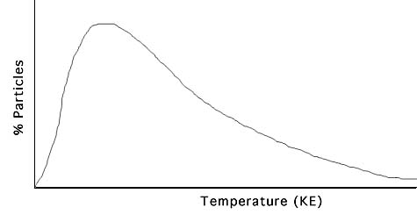  Distribution of Molecular Kinetic Energy  300 K  Heavier gas species | Distribution of Molecular Speed  Velocity (m/s)  Heavier gas species
v. Using the relationships determined in (i) and (ii), explain why these two graphs look different. (Use your text and the “Energy Histograms” for support).

f. Review and synthesis of KMT: Your books states that:

Measurements indicate that the average speed of oxygen molecules in air at 20°C is an amazing 1700 km/hr! At these speeds, the odor from a hot cheese pizza in Washington, D.C., should reach Mexico City in about 115 minutes. That does not happen, however, because… (pg. 420).

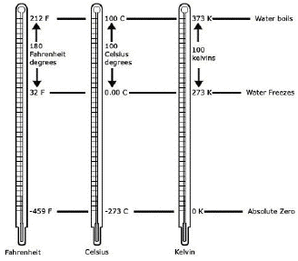
- What is air temperature in the above scenario in Kelvin (Hint: You book states that Absolute zero, 0°C is measured to be 273.15 K and these temperature measurements have the same scale, i.e. a shift of 1°C will result in a shift of 1 K)?

$$20\deg{C+273.15 degC=293.15 K}$$

- What is the average speed of these molecules when measured in units of meters per second (m/s) (There are 1000 m in a kilometer)?

$$\frac{1700 km}{1 hour}×\frac{1000 m}{1 km}×\frac{1 hour}{60 minutes}×\frac{1 minute}{60 seconds}=472 m/s$$

- Do either species in the simulation have an average speed close to that of oxygen molecules in air (Hint: Review your data from Table 1)?

- In your own words, explain why an adult walking in Mexico City won’t smell the D.C. pizza ever (Use the definition of the kinetic theory).

