Reflections:
Put the energy diagram after soliciting their prior knowledge about liquids, so that we can talk about KE and IMFs in the context of their thinking. Make sure to hold the groups accountable for their mini-presentations and that kids aren’t just copying each other’s work (i.e. Thomas and Zach copying Martin and Gabby’s explanation of the evaporation process).
- IMF better described using Science theater where one student needs to have lots of KE to break away from all of the attractions to the other students before he can escape.
- Have students raise one hand as their positive side and leave the other hand down as a negative side.
- Amount of group time in the library was good. Ask them to read 13.2 and then construct the diagram before asking them to explain it.

Bellwork:
Identify where the lower energy molecules are in this diagram, the highest energy and the average kinetic energy of the system.

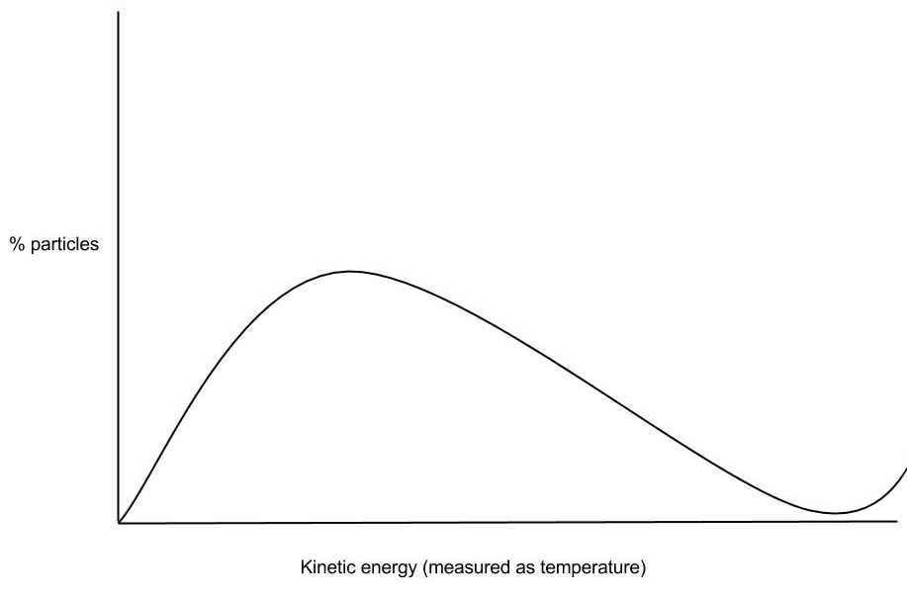
- What are some of the physical properties that distinguish a liquid from a gas and from a solid?

- Using your knowledge of the average kinetic energy of gases’ relationship with temperature, consider how the increase of average kinetic energy of the liquid’s molecules affect the temperature of the system.
    - What other factors need to be considered in order to determine how much energy is needed to cause a change in state to occur?

- What is meant by vapor pressure? What happens to vapor pressure as temperature increases? Explain.

- Evaporation and boiling.
Read the section for one of these concepts and write down your key take-aways. Once you’ve completed this, construct a story board of the evaporation or boiling process. You will explain this process to a new partner.

Evaporation notes:

Boiling notes

Work as a small group to answer these questions.

- With a dropper, you drop a small amount of rubbing alcohol on your friend’s hand. With another dropper, you drop a small amount of water on their other hand. The rubbing alcohol evaporates first.
    - Why is this the case?

    - Your friend complains that his hand that had the rubbing alcohol on it is now cold. Why is this the case?

- You’ve recently travelled out west to go trekking high up in the mountains and you notice that your spaghetti noodles are taking a long time to cook, even though the water is boiling. Your friend suggests that your fire isn’t hot enough. Another suggests that you got a bad box of noodles. Are either right? How could you explain the situation to them?

